Year 9 Imaging
Table of Contents
Year 9 Imaging 1
Things You Already Know 2
Cameras 4
Pinhole cameras 4
Lenses 4
Ray Diagrams 5
Real Cameras 6
Electronic Light Detection 7
The Eye 10
Short and long Sightedness 10
Colour Vision 12
Colour Mixing 14
Television 16
CRT 16
Plasma 17
LCD 17
OLED 18
Colour Space 18
Em Spectrum 19
Digitisation 19
Telescopes 20

Things You Already Know
- Light is a wave.
- Waves transfer energy.
- Unlike mechanical waves like sound that require particles to propagate, light can pass through a vacuum.
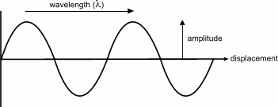
- Waves have the properties; amplitude (A), wavelength (λ), frequency (f) and wavespeed (c).
- Frequency is the number of oscillations per second measured in hertz (Hz).
- Frequency is related to the time taken for one oscillation (T) by:
$$f=\frac{1}{T}$$
- Frequency, wavelength and wavespeed are related by the wave equation:
$$c=λf$$
(remembering that nothing between symbols means that they are multiplied)
- Light in a vacuum travels at the fastest speed allowed in the universe; three hundred million metres per second.
- Light in air travels slightly slower, but at the number of significant figures we use it is still 3 hundred million metres per second.
- In a single medium, with a uniform density, light travels in straight lines.
- Light changes direction when it reflects. Where Specular Reflection occurs (mirrors) the angle of incidence (i) equals the angle of reflection (r), measured from the normal. Where Diffuse Reflection occurs (microscopically rough surfaces) the light reflects in every direction.

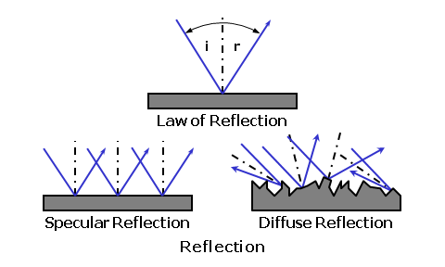
- Light also changes direction when it crosses into a different medium at an angle other than 90º to the boundary. This is called Refraction. Refraction occurs because of the light’s change in speed when it enters a medium with a different optical density. (In Year 8 we discussed this in terms of the tractor crossing onto a muddy field analogy.)
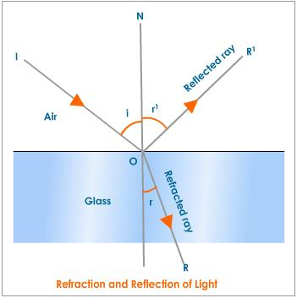
- Where light enters a material with a higher optical density (e.g. air to glass). The light bends closer to the normal.
- Where light enters a material with a lower optical density (e.g. glass to air). The light bends away from the normal.
- A portion of the light also reflects (see diagram). Expensive imaging optics (good telescope and camera lenses) are coated to minimise the amount of reflection.
- We see the images in flat mirrors as being an equal distance behind the mirror because your brain does not realize that the light has changed direction at the mirror and interprets the light from the mirror as coming from an object behind the mirror.
- Images can only be seen in reflections where specular reflection dominates.

Cameras

Pinhole cameras
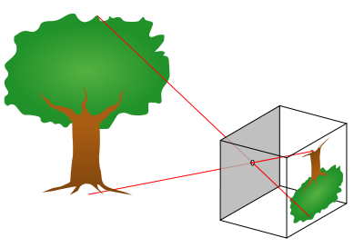
Pinhole cameras produce inverted, real images. The image is real because the light rays are actually found where the images form. This is in contrast to mirrors where the image is behind the mirror where there are no rays. Flat mirrors form virtual images.
Real images cannot be seen directly by eye, a screen is necessary. The reason is that your eye contains a lens system which creates its own real image, we will return to this later.
The reason that a pinhole works where a larger hole does not is that a focused image requires a one to one relationship with the object. That is, the rays that form one point of the image must have originated at one corresponding point on the object. A large hole would allow rays from one point on the object to spread out and overlap on the image, the image would be blurred.
If we placed an electronic light detection system or light sensitive chemical film where the image forms we could produce a photograph. However, so little light gets through the pinhole that we would have to wait a long time for enough light to reach the detector for a good photo to form. In this time the object may well move, once again giving a blurred picture.
The problem of too little light entering the camera is solved using a lens.

Lenses
Lenses can be converging or diverging, which corresponds to their being convex or concave shaped.
Convex lenses change the direction of light such that light radiating out from one point will converge back to one point. Diverging lenses spread light out further, although the rays can still be traced back to a single point, the rays are not actually found at that point (virtual).
It should be obvious, then, that a converging lens placed at the opening (aperture) of a camera will solve the pinhole camera problem; all of the light entering the camera from one point on the object will converge back to one point on the image.
There is a problem, however, the distance between the lens and point where the light converges to form a focused image varies with the distance between lens and object. Only objects at one particular distance from the camera can be in focus.
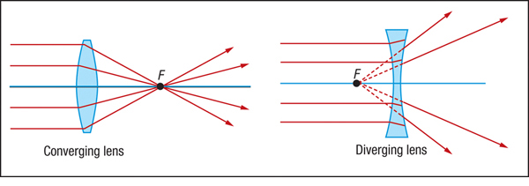
The closer an object is to the lens the more sharply its rays will be diverging when they enter the lens. Strongly diverging rays will produce a focused image further from the lens.
Rays from objects really far from the lens will barely be diverging at all when they enter the lens. We can imagine that the rays from distant objects are parallel when they enter the lens.
Parallel rays entering a lens always converge at a set distance from the lens, this distance is called the focal distance, and a point the focal distance away from the lens along the axis that passes through the centre of a lens (principal axis) is called the focal point (F), see diagram.
The closer the focal point to the lens the stronger the lens. This leads to the measurement of lens strength in dioptres (D) being given by:
$$lens strength= \frac{1}{focal distance (measured in metres)}$$
The calculation is the same for both converging and diverging lenses, but the focal distance for diverging lenses is negative.

Ray Diagrams
For sufficiently thin lenses we can use three rules for how light travels through a lens to work out where the focused image of an object will form behind a lens.
These three rules are:
- Light entering the lens parallel to the principal axis will exit through the focus.
And, because light travels along the same path whether it is propagating left to right or right to left,
- Light entering the lens through a focus must exit parallel to the principal axis.
Finally
- Light through the centre of the lens does not bend.
Applying these three rules to three of the rays leaving the top of an object allows us to work out where they converge and therefore where the top of the image is. See diagram.
Note that the image is real, the rays actually go there, and is inverted.
Twice the focal distance (2F) is marked on the diagram because an object at 2F will produce a symmetrical diagram with the object and images the same size and distance from the lens. The further the object is from the lens the closer the image will get to F and the smaller it will be.

Real Cameras
Cheap (e.g. webcams) cameras often deal with fact that only objects at a particular distance will be perfectly in focus on the image by ignoring it. These cameras are designed to give a focused image at the distance they are most likely to be used at.
Most cameras, including most phone cameras, have a system that moves the lens backwards and forwards so that the distance between lens and light detector is altered until the centre of the image is in focus (autofocus).
The light detector was originally glass smeared with light sensitive chemicals (usually silver chloride), later it became be a plastic film containing the same light sensitive chemicals, but today is more likely to be electronic.
All light detection systems, including that in our eyes, only really work well when the correct quantities of light fall upon them. Film, in particular, only worked with very particular quantities of light.
There are two ways of controlling the quantities of light that enters the camera:
- Shorten or lengthen the time that the camera is open to the light while taking the picture (shutter speed). Longer shutter speeds increase the risk of movement blurring the picture.
- Use a moveable diaphragm to alter the size of hole that the light enters through (aperture). A smaller aperture makes the camera more like pinhole camera and as a result a wider range of distances (depth of field) either side of the ideal is in focus.
Films could be made to react to more or less light, slow films needed more light and gave finer pictures, fast films needed less light and produced grainy images. Films were rated on an ISO (International Standards Organisation) scale from 50, really slow to 800 or even 1600, very fast. Electronic detection systems can alter their sensitivity to light, and use a similar scale.
A modern camera will usually choose a sensitivity setting somewhere between 100 and 3200 , a shutter speed between 0.5 seconds and 1/750th of a second and an aperture between 2 (wide open) and 16 (small) to give you the best picture. A more creative photographer will use the camera controls to choose for themselves.
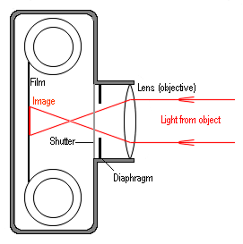

Electronic Light Detection

Semiconductors
In metals no energy is needed to free an electron to allow it to move through the material. All metals conduct electricity.
In most non-metals the energy needed to free the electrons would break the bonds in the material. Most non-metals do not conduct electricity.
Semiconductors are in between the two and can therefore be found in the middle of the periodic table between metals and non-metals. Germanium is a semiconductor, but the main one, the one that almost all modern electronics is made from, is silicon.
Electrons in pure silicon are not free to move about, but add a small amount of energy, or add the right impurity to the silicon, and the electrons can conduct electricity.
Precisely adding different impurities allows us to make electronics. Using the fact that in pure silicon energy is needed to free the electrons, and light carries energy, allows us to detect light with silicon. Combining the two allows us to make the light sensors found in digital cameras.

Charge Coupled Devices
The first technology capable of producing a single slice of silicon that could measure light in different places across its surface, and therefore measuring the information necessary to produce a picture, was a Charge Couple Device or CCD.
The very first CCD was produced by George Smith and Willard Boyle in 1969, it had eight pixels, it could measure the light in eight places across its surface. Today most digital cameras have more than 12 million pixels (12 megapixels), and where modern cameras are colour they actually have three times that number because each dot has to measure the three primary colours separately.
Today there are other silicon device types that can do the job like CMOS (complementary metal oxide semiconductor). But the detectors tend to be referred to as CCDs even if they are not.
One of the limitations of modern electronics is that all of the connections must be made using minute gold wires on the surface of the silicon. This is a real problem for CCDs because the wires block the light out. Most CCDs just accept this limitation, but CCDs designed for use in telescopes and a few CCDs in good cameras actually thin down the silicon crystal that the CCD is made on so much that the CCD can detect the light falling on the back of the device, that way the wires don’t get in the way. These are called back-thinned or back-illuminated CCDs.

JPEG
Silicon based CCDs can measure light from the near infrared through to ultraviolet by counting the number of electrons given enough energy to become mobile. By doing this across a grid of detectors the pattern of light and dark falling on a CCD can be converted into a set of whole numbers (digital). For colour pictures this is usually done for each primary colour (see Colour Mixing). These numbers, along with information about the date, time and camera settings, form what is called the RAW picture file. This file is usually digitally compressed to produce a JPEG file.
In the picture on the next page (a) is a black and white aerial photograph, (b) is the centre of that image expanded and (c) expanded again so that you can see how the picture is made up of a grid of light and dark blocks – pixels. (d) Shows how those light and dark blocks are digitized (turned into numbers). Dark areas have low numbers assigned to them and bright areas high numbers.
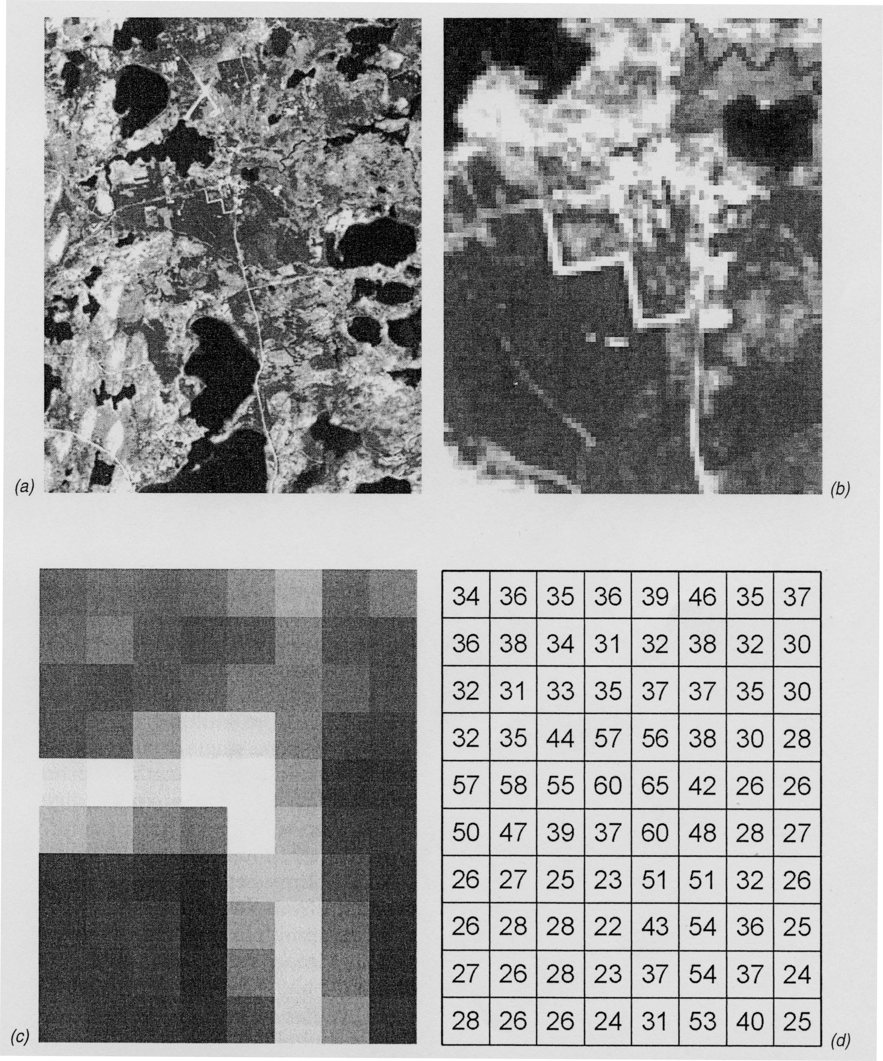

In computing compression means making the file smaller. There are two forms of compression; lossless compression uses clever coding to make the same information take up less space. JPEG files (and MP3 music files) use lossy compression, i.e. some information is thrown away. JPEG compression uses the idea that we are better at noticing changes in bright and dark than we are at noticing changes in colour. Thus a lot of the colour information is ditched, but the light and dark information is kept. Unless the compression is too high, we do not even notice that much of the information needed to create a complete picture is missing.

The Eye
Not surprisingly, because they do the same job, the human eye bears a lot of resemblance to a camera.
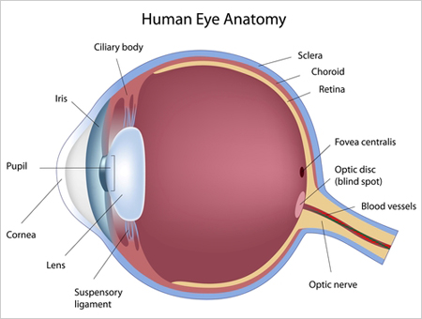

Two big differences are that the light detection surface (retina) that the image is projected onto is curved and the lens is flexible.
The cornea does most of the bending of the light and then, rather than focusing by moving a lens back and forth as a camera does, focusing is carried out by stretching the lens to make it thinner with the ciliary muscles (“ciliary body” in diagram).
The retina also differs from a CCD in that it varies across its surface in the number and type of light detectors. The highest density of light detectors, and particularly the highest density of colour detectors, is found at and around the Fovea because that is where the image of the object that we are directly looking at will form.
We have a blind spot where the nerves and blood vessels come together to exit the eye, but it is off centre and falls in a different part of the image in each eye, so we don’t notice.
We have two eyes because the brain can process the slightly different images that each eye receives to produce a three dimensional image. (3D TVs, games or Cinema all have some method to ensure that each eye receives a slightly different image from the same flat, 2D screen, fooling your brain into thinking it is seeing 3D.)

Short and long Sightedness
A common defect of the eye is for it to be the wrong shape (more oval than round), this can lead to distant objects focusing in front of the retina not on it, short sightedness, or, more properly, myopia.
The opposite, long sightedness or hyperopia, where close objects focus behind the retina, can be caused by the lens or eye being the wrong shape, but is more commonly caused by old age. In this case the lens is no longer flexible enough to spring back completely when the ciliary muscles relax.
The symptoms of both can be cured by adding an extra lens, in the form of glasses or a contact lens, in front of the eye, or by altering the shape of the cornea with laser eye surgery.
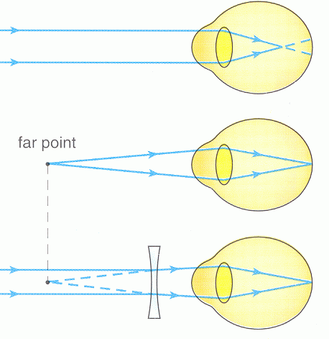
Light from a very distant source is treated as parallel.
For myopia parallel light focuses in front of the retina, so the furthest point that can be focused (far point) is not infinitely far away.
This can be corrected with a concave lens.
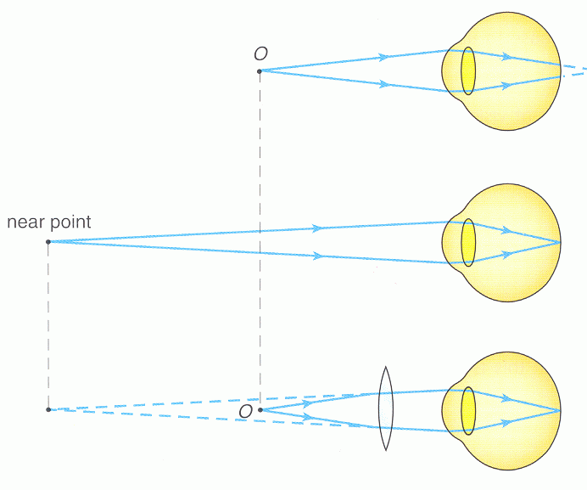
Light from a close source is strongly diverging.
For hyperopia strongly diverging light focuses behind the retina, so the closest point that can be focused (near point) is too far away.
This can be corrected with a convex lens.

Colour Vision
Human eyes have four types of light detector cells.
The most common are rods, these work across the whole spectrum and so can only tell bright and dark apart, not colours.
The other three types are S,M and L cones. These do react differently to different wavelengths of light and so give us colour perception (cones do not work in low light – we see in black and white in low light).
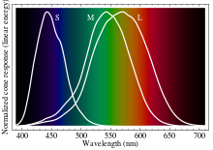
Note that violet and deep red show up as black because computer monitors cannot produce them, see TVs.
They each react more strongly to short (S) wavelength visible light (violet and blue), mid (M) wavelengths (green) or long (L) wavelength (red) light.
Looking at the image above a greeny blue (430nm) would activate the S and M similarly, but the L not quite as much, where yellow (570nm) will activate the L and the M similarly, but the S not at all. Purple is not in the spectrum because it is a mixture of red and blue light, and so the S and L would activate, but not the M.
The combination of the outputs from the three cone types along with information on how bright and dark from the rods allows the brain to distinguish around 10 million colours.

Colour Blindness
It is possible but rare for genetic defects to lead to a person having no or just one type of operating cone cell and as a result be unable to distinguish colour. Similarly having only two types of operating cone means that only some colours are distinguishable.
Much more common is “Anomalous Trichromacy”, that is all three cone types are present and operating but some defect has led the sensitivity of the L and M cones to peak at almost the same wavelengths. If they peak in exactly the same place the output from the two is indistinguishable, and reds and greens cannot be told apart. This is fairly common in boys, with up to 8% of European males having problems separating reds from greens.
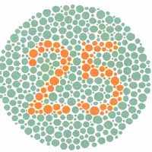 | 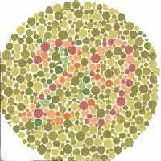
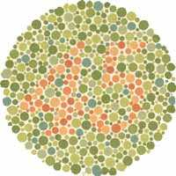 | 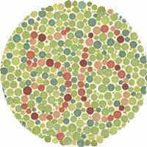
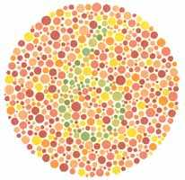 | 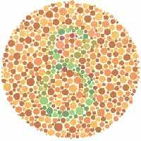
The above are Ishihara colour blindness tests, the numbers in each circle are clear if you have no problem distinguishing reds and greens.

Colour Mixing
White light from a hot object like the sun or a filament lamp is made up of all of the wavelengths of light that the human eye can detect, and, as you know, can be split into a spectrum using a prism.
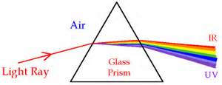
But the human eye only has three different colour detectors so it is possible to fool the eye into thinking it is receiving full white light by just sending it the three wavelengths that match the peaks of the three cone sensitivity curves, i.e. blue, green and red.
We call these three the Primary Colours.
But if you look at the SML graphs in the colour perception section you can see that if we just send red and green light to the eye the M and L cells would activate, just as they would if the eye were receiving the wavelength that corresponds to yellow. Red and Green light together is perceived by the eye as Yellow. Blue and Green together is perceived as a greeny blue, called Cyan. Red and Blue together is perceived as a purple, called Magenta.
Yellow, Cyan and Magenta are called the Secondary Colours.
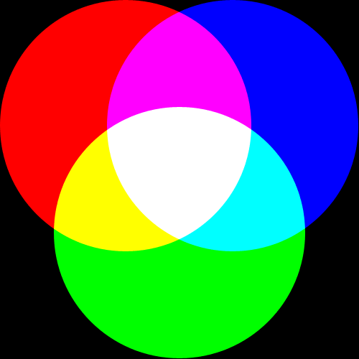
The perceived effect of overlapping circles of red, green and blue light
In fact just shining combinations of the three primary colours into our eyes can fool us into thinking we are seeing most possible colours. This is called Additive Colour Mixing.
Dyes, paints and colour printing work the opposite way. They absorb (remove) wavelengths from the white light bouncing off them and the colour that we perceive the dye to be depends on what light is left.
So a yellow dye absorbs the blue light falling on it. The reds and greens reflect to be perceived by us as yellow. Under a blue lamp the yellow would seem black because no light would be reflected.
Magenta dyes absorb green light, and Cyan dyes absorb red.
Making colours from combinations of dyes (particularly the three secondary colour dyes) is called Subtractive Colour Mixing.
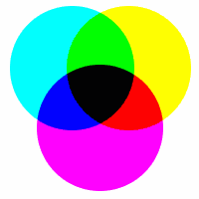
The perceived effect of white light reflecting from overlapping circles of cyan, magenta and yellow dye.

Pass-band Colour Filters absorb all colours of light passing through them except their own. A red filter absorbs green and blue light, passing only red.
A cheap yellow filter (a theatre gel for example) will only absorb blue, leaving red and green to enter our eyes and be perceived as yellow. An expensive Pass-band Yellow Filter will only allow through those wavelengths of light that correspond to yellow.
The complexity of understanding mixing colours and using filters explains why other, non-scientific subjects might tell you that Yellow is a Primary Colour. It is not, it is a secondary colour.

Television
There are four basic types of television technology:
Cathode Ray Tube
Plasma
LED lit LCD
OLED
All use the Additive Colour Mixing process, so each pixel on the screen is actually made up of three pixels, a red, a blue and a green – or often four pixels a red, a blue and two greens. They just differ by how the coloured light is created and controlled
High Definition (HD) is not a technology type, but rather a pixel count; 1920 across by 1080 down or 2 Megapixels, and replaces standard definition at 720x576.

CRT
The CRT TV was pioneered by Marconi in Britain and was used exclusively by the BBC from 1937, replacing the mechanical system produced by John Logie Baird.
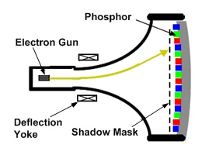
For a colour TV an evacuated (vacuum) glass tube has three electron guns at one end that fire out three electron beams. These beams are scanned across the screen at the front using magnets. At each pixel, each beam energises a primary coloured phosphor dot so that it glows. The more intense the beam, the brighter the dot glows.
The shadow mask, a fine metal mesh with holes to match the phosphor dots, ensures that the beams only hit the phosphor dots they are supposed to.
Each pixel will have stopped glowing by the time the beam scan re-energises it, but with moving pictures all this happens too fast to be noticeable. With still images some flicker is noticeable.
The large size and weight of the tube makes CRTs undesirable now that other technologies are available.

Plasma
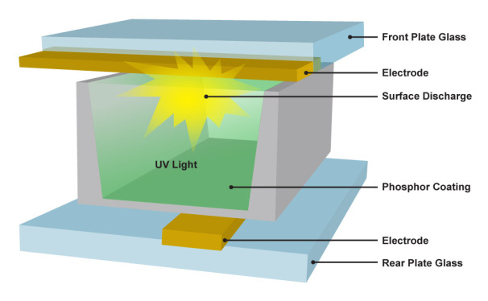
Plasma TVs are made up of three cells at each pixel with contain a low pressure gas. When electricity is passed through the gas in the cell a plasma is formed. The plasma produces UV light which energises a primary coloured phosphor producing light.
Plasmas have excellent pictures, but are still heavy because of the need to protect the low pressure seal. The plasma in each cell can eventually wear away the phosphor, making plasma TVs very vulnerable to having still images left on screen permanently burnt into them.

LCD
Most modern TVs and all computer monitors are LCD. Liquid Crystal Displays differ from the other technologies in not producing their own light at each pixel. Instead they have bright lights at the back which, at each pixel, is allowed, or not, to pass through primary coloured filters.
Most TVs that claim to be LED, are actually LCDs but with LED lights behind. LED lighting is more efficient and gives better colour than the hot lamps that lit the first LCDs.
The light in an LCD is controlled by utilizing the fact that light, being a transverse wave, can have different orientations. That is the wave could be oscillating vertically, horizontally or at any angle in between. Many transparent materials can be made to allow light to pass that is oscillating in one particular direction only, this is called polarising the light.
If a pair of polarising materials are placed perpendicular to each other (crossed) no light can pass. But if a third layer of polariser is placed between them at an angle some light will pass depending on the angle. There are certain organic materials whose polarization angle can be changed by applying a potential difference, these are the liquid crystals. LCDs work, therefore by having crossed polarisers with liquid crystal between them, where a potential difference is applied to the liquid crystal light gets through to light up that pixel.
LCD TVs are thin and light, but have one drawback, it is impossible to prevent the back light from leaking through, so what should be black on an LCD is really only grey.

OLED
This may well be the coming technology – Organic Light Emitting Diode TVs.
LEDs are electronics which produce light at a very specific wavelength when electricity is passed through them. Twenty years ago making blue LEDs even from semiconductors was tough – today LEDs can be made in a range of colours from organic polymers.
Screens made from pixels which glow with the correct colour and very efficiently when electricity is passed though are obviously exactly what we want. However, although OLED screens have been around in MP3 players and phones for some time manufacturers have not found it easy to reliably make large OLED screens.
LG have been the pioneer, even launching a curved screen OLED TV, the pictures are amazing, but the price is still high.

Colour Space
It was mentioned earlier that deep red and violet cannot be made by computer screens, this is because they use red, not deep red pixels and blue not violet, so colours either side of these two cannot be made. There are good reasons not to worry about this. For example, the eye has far fewer S cones than L cones so cannot see violet all that well anyway, but you should be aware that your TV or Monitor can make all of the colours in its colour space, not all of the colours.
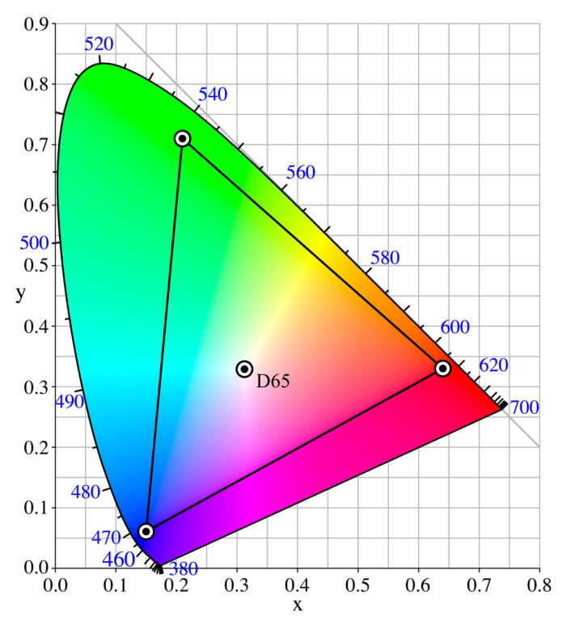
If the curved shape represents all of the colours a human can see, the triangle represents the colour space a TV can produce where the dots are the colours of each primary pixel.

Em Spectrum
Although we have mentioned UV and near infrared so far our imaging has been restricted to visible light, but we all know the pictures can be made with X-rays and you may know that radar images are produced with microwaves. Visible light is only a tiny part of the electromagnetic spectrum and every part can be used for imaging.
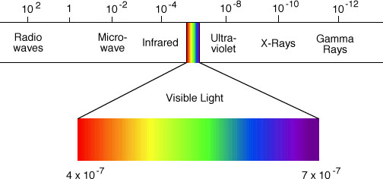
Note that the numbers in this diagram are the wavelengths in metres. Because the numbers involved with light can be huge or tiny we always use standard form or engineering form (the powers of 10 are always multiples of 3 so the first number is not always a unit followed by a decimal place as in standard form).
Because the speed of light is constant at 3 × 10⁸m/s it is easy to convert between wavelength and frequency using the wave equation.
E.g. If the wavelength of blue light is 410 × 10⁻⁹m (410nm) what is its frequency?
c = λf
so:
$$f=\frac{c}{λ}$$
Putting in the numbers gives:
$f=\frac{3×{10}^{8}}{410×{10}^{-9}}=732×{10}^{12}$Hz
Finding uses for each part of the EM Spectrum is a good research HW so find it out for yourself please.

Digitisation
Although strictly a communications rather than imaging topic digitization is included here because we have, after all, been talking about digital cameras.
Something that is digital is something that is expressed in whole numbers, digits, and is the opposite of analogue where the thing can take any value. It is like comparing discrete and continuous variables.
More specifically something that is digital is usually a whole number in binary, which is counting in base two rather than base ten. Binary is written as ones and zeros only, for example 126 in binary is 1111110. Binary has the big advantage for computers that a one can be “on” and a zero can be “off”, so a computer is then just as huge number of electronic switches turning on and off. 126 to a computer is then “off”,”on” ,”on” ,”on” ,”on” ,”on” ,”on”,”off” – the first “off” is because in computers the ones and zeros always come in eights, eight ones and zeros is called a byte (as in a Terrabyte hard drive – 10¹²bytes).
The world is analogue, computers are digital, the interfaces between them, like digital cameras are always turning the continuous variables of nature into the discrete variables of computers.
In communications digital has an extra advantage; it is very hard to mess up a digital signal. If you have listened to medium wave radio you know it is easy to mess up an analogue signal, because that is what old fashioned radio is, but your Sky TV, which is digital, is either perfect, or not there at all, there is no in between.
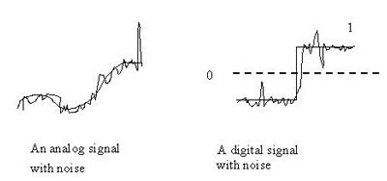
The reason is shown in the diagram, if a continuously curving analogue radio signal picks up some rubbish (we call it “noise”) as it travels how can the receiver tell what is noise and what is signal? Answer it can’t. But with digital, unless the noise is really terrible the receiver can still tell what was supposed to be a one and what was supposed to be a zero. Today almost everything that is analogue – you talking into a telephone – is digitized before it is sent and is then converted back to analogue at the other end, your friend’s phone.

Telescopes
Finally the details of telescopes and space should be covered in one of your rotation lessons.
However, two ideas from telescopes connect directly to the imaging course;
- Different types of telescopes exist to produce images of space from the whole of the EM Spectrum, but some portions of the spectrum do not make it through the atmosphere so the telescope itself must be put into space.
- Having taken images in different portions of the spectrum astronomers still want to put them together to form a single colour image that they can examine. These images are called False Colour Images because the colours are not what you would see if you looked directly at the object in question.
You may get the chance to produce False Colour Images from original black and white astronomical pictures in class. If you do not you can always try it yourself, the instructions are in the Supplementary Material in the Course Notes section of the Y9 physics course on the VLE and the software you need is available in Vibert.
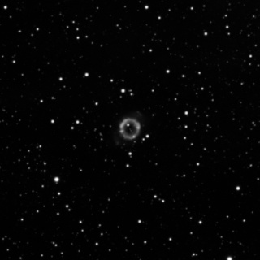 | 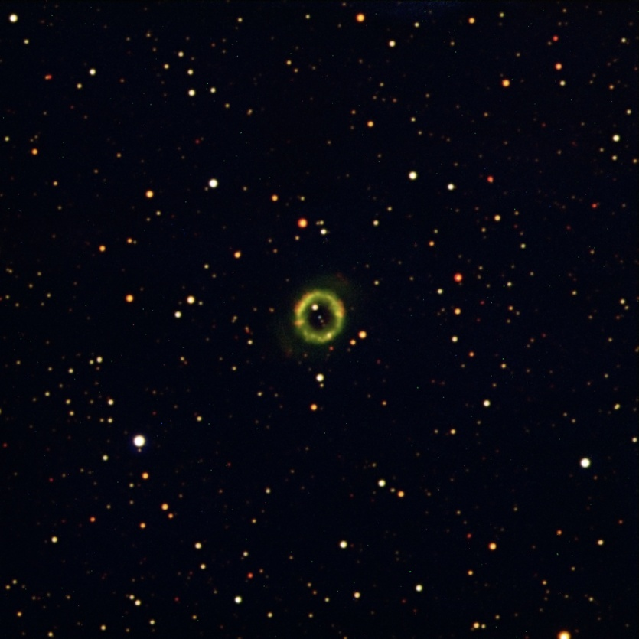
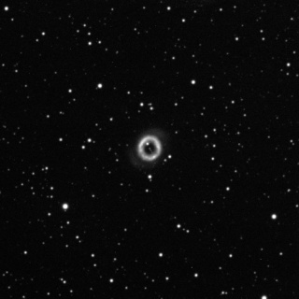
Three images of this nebula (a glowing cloud of gas in space) were each taken in a different portion of the EM spectrum and were combined to make the false colour image on the right

Picture from http://library.thinkquest.org/18160/wavehard.htm
Picture from http://www.opticampus.com/cecourse.php?url=nature_light/
Picture from http://www.tutorvista.com/content/science/science-ii/refraction-light/refraction-light.php
Picture from http://en.wikipedia.org/wiki/Pinhole_camera
Picture from http://www.digikey.com/us/en/techzone/lighting/resources/articles/optical-considerations-for-bridgelux.html
Picture from http://physicsed.buffalostate.edu/SeatExpts/EandM/con_lens/solution.htm
Picture from http://www.physchem.co.za/OB11-wav/instruments.htm
Wikipedia
Remote Sensing and Image Interpretation, Lillesand, Kiefer & Chapman, 2008
http://searchengineland.com/eyetracking-seo-fad-fact-or-fiction-98799
http://share.sja.edu.hk/~phy/humaneye.htm
http://en.wikipedia.org/wiki/Color_vision
http://en.wikipedia.org/wiki/Color_vision
http://www.toledo-bend.com/colorblind/Ishihara.asp
http://www.gcsescience.com/pwav38.htm
http://www.ladyada.net/learn/arduino/lesson3.html
http://www.knowledgerush.com/kr/encyclopedia/Primary_pigments/
http://www.hometheaternetwork.com/HTN_HDTVsed.htm
http://recent-news1.blogspot.com/2012/03/digital-displays-explained.html
http://www.thephotoforum.com/forum/beyond-basics/236919-color-purple.html
http://schoolworkhelper.net/light-energy-and-photosynthetic-pigments/
http://ericsonfp.wordpress.com/2007/07/06/digital-broadcasting-why-digital-a-qualitative-review/
Pictures of NGC 6337 taken by Victoria College using the Faulkes Telescope

