Pendulums
It is a common misconception that pendulums are used to power grandfather style clocks, actually there are normally one or more slowly falling weights that power the clock.
What form of energy is being converted into kinetic energy by the falling weights?
……………………………………………………………………..
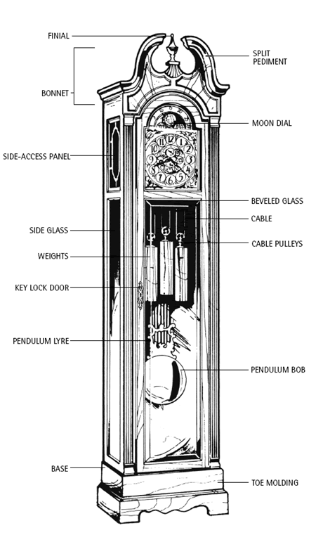
Image from grandfatherclocks.com
The pendulum is included in the clock to keep time. This is because pendulums have the property that the time of one swing is largely determined by the length of the pendulum.
Find out which famous scientist first studied the properties of pendulums and which century he lived in.
……………………………………………………………………..
Task 1
The scientist who you are going to identify on the page before had a theory that the time it takes for a pendulum to swing does not change with the size of the swing. Design an experiment to test this (hint use a long string).
Then, in your own words, describe how the experiment will be performed below.
Independent Variable …………………………..
Dependent Variable …………………………..
Important Control Variables …………………………..
…………………………..
…………………………..
Number of tests …………………………..
Number of repeats of each test …………………………..

Method:

………………………………………………………………………….
………………………………………………………………………….
………………………………………………………………………….
………………………………………………………………………….
………………………………………………………………………….
………………………………………………………………………….
………………………………………………………………………….

It is important before carrying out a new experiment to stop and think through if there is any possible way that experiment could injure yourself or someone around you. If you can think of some ways that you might come to harm, then you also need to think about what precautions you need to take to reduce (mitigate) the chance of injury. This is your risk assessment:

Complete a General Risk Assessment for Performing Pendulum Experiments in a Classroom:
Process that could pose a risk | Mitigating Actions

In the space below, or on a separate piece of paper, draw your table and then carry out the experiment.

Does your experiment need a graph? If it does draw it and include the graph in your folder.
How well does your experiment confirm the idea that the time for one swing of any particular pendulum does not change?
………………………………………………………………………….
………………………………………………………………………….
………………………………………………………………………….
………………………………………………………………………….
Having done the experiment, what problems did you encounter, what would you change?
………………………………………………………………………….
………………………………………………………………………….
………………………………………………………………………….
………………………………………………………………………….
………………………………………………………………………….
………………………………………………………………………….
Extra Study Tasks:
To be completed as Homework by the end of the rotation.
Write a report (including references to all of your sources of information) on either:

Escapement. What an escapement mechanism is, how it works and how it has developed. See if you can find out how the escapement used in the clock that strikes Big Ben works.
Or:
Quartz Oscillators. Pendulums were only superceded after the 1920s by quartz crystal oscillators, how do they work and in particular what is piezoelectricity?
Or:
Leap Seconds. Find out what they are and why they have been under review in the past few years.

The Chandelier in Pisa Cathedral, next door to the Leaning Tower, reputedly used for the earliest experiments on pendulums (photo Dr Cooke)
Task 2
In year seven you were told, and experimentally demonstrated, that the distance between the pivot point and the centre of the pendulum mass determined the time it took for the pendulum to swing (providing the mass was heavy compared to the string). In Task One you have looked at whether swing size makes a difference. In this task think of another factor that might change the time for one swing and design an experiment to test it.
Then, in your own words, describe how the experiment will be performed below. Does this new experiment carry any risks that were not in your general pendulum assessment. If it does list them and the mitigation.
Independent Variable …………………………..
Dependent Variable …………………………..
Important Control Variables …………………………..
…………………………..
…………………………..
Number of tests …………………………..
Number of repeats of each test …………………………..
Method:

………………………………………………………………………….
………………………………………………………………………….
………………………………………………………………………….
………………………………………………………………………….
………………………………………………………………………….
In the space below, or on a separate piece of paper, draw your table and then carry out the experiment.

Does your experiment need a graph? If it does draw it and include the graph in your folder.
Does the experiment you carried out show that the factor you chose affects swing time? Check your conclusions with those of other groups?
………………………………………………………………………….
………………………………………………………………………….
………………………………………………………………………….
………………………………………………………………………….
Having done the experiment, what problems did you encounter, what would you change? Are there other factors you could test?
………………………………………………………………………….
………………………………………………………………………….
………………………………………………………………………….
………………………………………………………………………….

Simple Harmonic Motion
The movement of pendulums is a type of motion that turns up again and again in physics – it is called Simple Harmonic Motion. Atoms in a crystal vibrate with simple harmonic motion, so do the springs in a car suspension.
Studying Simple Harmonic Motion in detail is A level work, but one of the equations that describes SHM for pendulums is easy:
That is:
The time for one swing (T) squared equals a constant (k) times the pendulum length (l).
In mathematics k is known as the constant of proportionality, and if things are arranged so that an experimental graph produces a straight line k is the gradient of the graph. (You might have to look back at your maths book to work out what a gradient is and how you calculate it).
Often in physics we want to know the value of the constant of proportionality because it tells us something about the physics of the system. In the case of a pendulum we can accurately calculate the Earth’s gravity from the value of k in the equation above.
To do this we need to do an experiment to measure the time of one swing for a range of different pendulum lengths and then plot a graph to get a straight line. However, if we do as you did in year seven and plot time for one swing against string length we will get a curve, so we have to do something clever; we plot the time for one swing squared on the y axis and length on the x axis, this should give a straight line graph.
The gradient of our straight line graph is k and:
Where g is the gravitational field strength and π is the pi you know from maths. So we can work out the strength of gravity. The big advantage of doing it this way is that air resistance has no effect on the answer, unlike when we try to measure gravity using things falling when air resistance is a problem
Task 3
Repeat your year seven experiment to find how the time for one swing changes as the length of the pendulum is changed. Count 20 swings each time, remember that a full swing is there and back again, and be careful to measure length from the pivot to the middle of the swinging mass.
Complete the table below or copy it out to produce your own. Calculated values should have the same number of significant figures as your measurements do.

Length (l) /m | Time for 20 swings /s |  |  | Average Time for 20 swings /s | Average Time for 1 swing (T) /s | Time for 1 swing squared (T²)  /s²
 | Repeat 1 | Repeat 2 | Repeat 3
0.300
0.400
0.500
0.600
0.700
0.800
0.900
1.000

Use graph paper to plot T² against l. Remember to think about your scale so that the graph fills as much of the paper as possible.
How good a straight line is your graph? Are the points close to your line of best fit the whole way? Are there any anomalies?
………………………………………………………………………….
………………………………………………………………………….
………………………………………………………………………….
………………………………………………………………………….
On your graph draw in a large triangle to enable you to calculate the gradient of your line of best fit.
Calculate your gradient:
Δy
Δx
x
y

On Earth the gravitational field strength g is 9.81N/m, using the equation on Sheet 7 this means that your gradient should have a value of 4.02s²/m.
Do you think your experiment agreed with 4.02s²/m? Why?
………………………………………………………………………….
………………………………………………………………………….
Extra Study Tasks

How is your extra study research task going?
Have you planned which task you will do?
I am going to cover ...........................................

Have you begun your research?
Search terms I have tried in Google
..................................................................................
..................................................................................
..................................................................................

You didn’t think that half an hour the evening before was going to be good enough when you had been given several weeks for the project did you?

If you are lucky enough to have access to one, programs like Microsoft OneNote are very useful for collating research notes. OneNote allows you to copy whole web pages or parts of web pages into one place, add your own notes and OneNote will keep track of where on the web you found your information so that you can include references in your final document.

Extra Study Task 2
Design a Cover page for this Project.

You may create a design by hand or use a desktop publishing package like Publisher.
The design can be as abstract as you like except that even an abstract design must convey something about time and pendulums. You might want to ask your art teacher if they have pictures/ideas that could give you some inspiration.
Task 4
This task is a repeat of Task 3, but done using a datalogger hooked up to a laptop. The necessary set up is shown in the picture below.
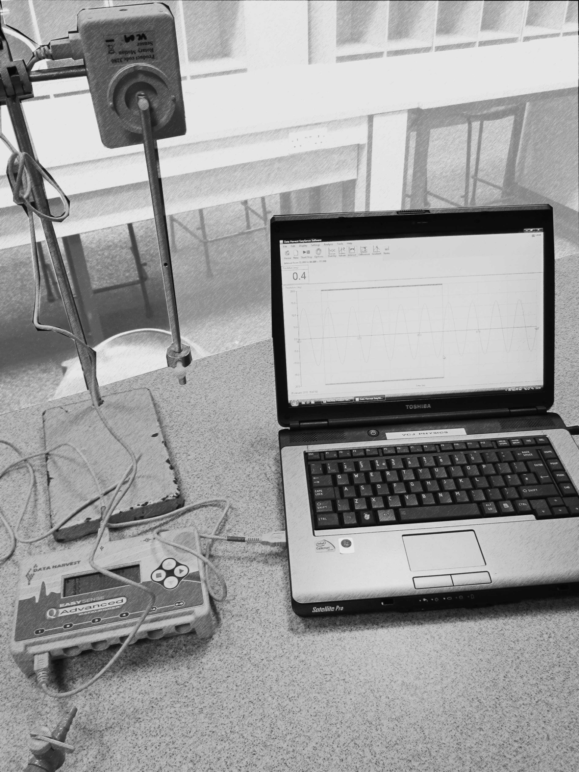
Datalogger on Meter and set to Pendulum and then connected to the Laptop with a USB cable
Laptop using Easysense software set to Graph for 10 seconds
Rotary Head with adjustable pendulum attached to datalogger
With the pendulum hanging still set the angle to zero using the grey zeroing button on the side of the Rotary Head. By default when measuring over ten seconds the Graph function will take a measurement every 50ms, is this often enough?
Once you have recorded a set of swings the Interval Button can be used to measure the time for five swings (remember to click it each time you do a measurement). You will need to decide what steps you will alter your independent variable (the distance between the pivot and the adjustable weight) in and then complete the table below.

Length (l) /m | Time for 5 swings /s |  |  | Average Time for 5 swings /s | Average Time for 1 swing (T) /s | Time for 1 swing squared (T²)  /s²
 | Repeat 1 | Repeat 2 | Repeat 3

Use graph paper to plot T² against l. Calculate your gradient.

How well do your points match a straight line of best fit for this graph?
………………………………………………………………………….
………………………………………………………………………….

Which seems to have produced the better graph, using the computer to make the measurements or timing by hand?
………………………………………………………………………….
………………………………………………………………………….

Can you think of any arguments in favour of the experiment that you timed by hand compared to this experiment?
(Hint - You might consider the number of swings counted and whether the weight on a string and the rotary head set up are really the same type of pendulum, which one compares best to the ideal pendulum which is a heavy weight concentrated at a point on an incredibly light string.)
………………………………………………………………………….
………………………………………………………………………….
………………………………………………………………………….
………………………………………………………………………….
………………………………………………………………………….
………………………………………………………………………….
………………………………………………………………………….
………………………………………………………………………….
Task 5
Open Task

If your experiments have over run in previous weeks and you are not completely up to date with task 4 complete then use this week, the sixth in the rotation to catch up.

If, however, you are up to date then your task is to design and test a method of using the light gates, dataloggers and laptops to time an ordinary pendulum as it swings.

On a separate sheet draw and label your design and write a short evaluation of your experiment design, comparing it to the design of task 4. If you couldn’t make the experiment work be honest and say so. Include this sheet in your project folder.

Hint – set the datalogger onto meter and pulse before connecting the USB cable to the laptop.

Note that if you do attempt this task the experiment sheet must be written up
Universal Time
It may surprise you to realise that pendulums remained the most accurate way to measure time until the 1930s, in fact pendulums were still measuring Greenwich Mean Time after the invention and first broadcast of television. A replica of one of the Greenwich clocks from the 1930s can be found above the stairs up to the great hall. The pendulum swings in a metal canister that was at a fixed low pressure so that pressure changes did not alter the time of the pendulum’s swing.
You may already realise that there is a connection between time and your position on the Earth. It takes 24 hours for the earth to rotate so that the Sun is back at the same point in the sky the next day and one rotation of the Earth is 360º. So if you know exactly when noon is in London, and exactly when noon is where you are according to the sun (ie when the sun is at its highest) then the difference between those times tells you how many degrees of longitude there are between you and London. For example, your local noon being one hour after London’s noon means that you are 15º west of London (360º/24h).
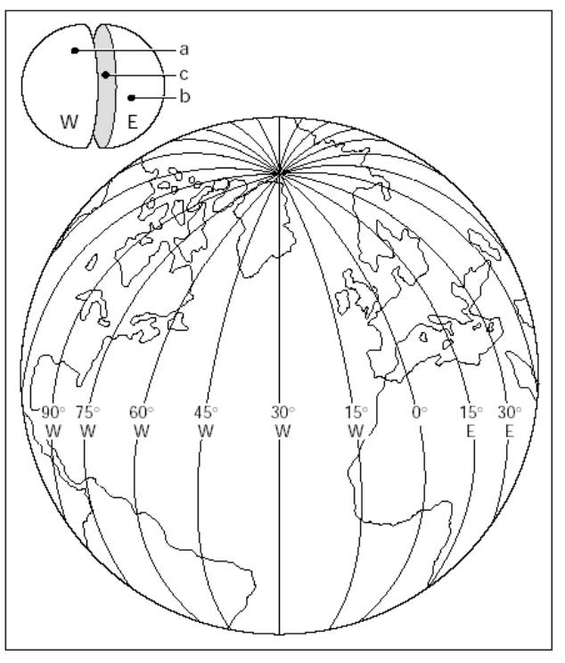
1 hour behind London corresponds to 15º west, which means that if you aren’t at sea you are either in Antarctica or the far West of Africa. Time tells you where in the world you are.
Picture from:
www.nssgeography.com
A conference in 1884 decided that all time and therefore all longitudes should be measured from the longitudinal line (meridian) that runs through the Royal Observatory in Greenwich. This means that Greenwich Mean Time is the same as Coordinated Universal Time (UTC) which is the time that every satellite and every server on the internet is set to.
Local noon in Jersey is roughly 9 minutes after noon at Greenwich, calculate how many degrees west of Greenwich that makes us
…………………………………………………………………………………….
…………………………………………………………………………………….
…………………………………………………………………………………….
…………………………………………………………………………………….

In Jersey clocks ran on Jersey time (i.e. 8 minutes 20 seconds behind GMT or UTC) until a law was passed switching us to GMT in 1898.
When the new clock was installed in the St Helier Parish church in 1862 it was originally set to GMT which caused uproar among Jersey Fishermen because it meant that the church clock and their tide tables (printed in Jersey time) did not agree. But the Ferry companies supported GMT for the island because it meant that their timetables did not have to change by 9 minutes between England and Jersey (the building of railways across Britain in the 1840s and 50s had meant all of the rest of Britain had already adopted GMT for the same timetabling reasons). It only took a month of protest for the clock to be moved back to Jersey time and there is stayed until 1898 (source: Geraint Jennings, St Helier Town Crier, December 2011).

Who do you think was right, the fishermen or the ferry companies? Why?
…………………………………………………………………………………….
…………………………………………………………………………………….
…………………………………………………………………………………….
…………………………………………………………………………………….

At sea it is obviously very important to know where you are, but out of sight of the coast you have no landmarks to help so a time based method of fixing your longitude would be brilliant. Unfortunately pendulums cannot be used reliably at sea.
Explain why
…………………………………………………………………………………….
…………………………………………………………………………………….

It was an inventor and clockmaker called John Harrison who eventually solved the problem in the 1760s by replacing the pendulum with an oscillating weighted wheel driven by an uncurling spring. In doing so he re-invented the watch – a clock that could be used even though it might be shaken about. By comparing the time in London according to Harrison’s watch with local time which was worked out by observing the sun or the stars ships’ navigators could work out their exact longitude.
The race to develop an accurate way of measuring longitude at sea and therefore win the huge cash prize offered by the Navy to anyone who could solve the problem is described in a well known book – “Longitude” by Dava Sobel.
One of the problems that Harrison, and anyone trying to make an accurate mechanical clock, had to correct for is thermal expansion. With pendulums if the rod holding the weight increases in length because it has warmed up the pendulum is longer and therefore swings more slowly.

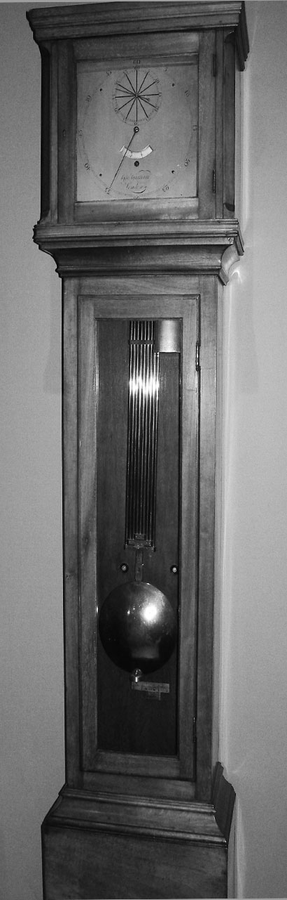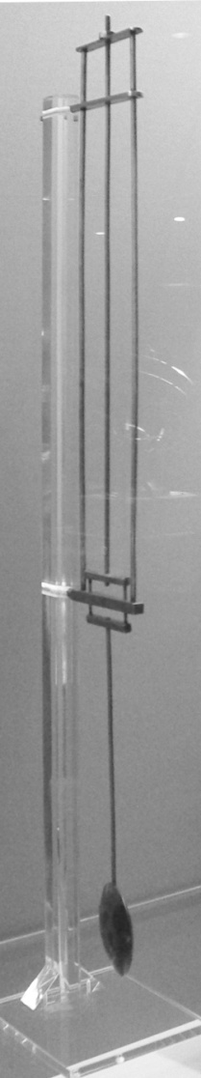
Top Bridge

Middle Bridge

Lower Bridge

Zinc

Iron

Left to right: A Harrison gridiron pendulum (Royal Observatory), a simplified gridiron pendulum (British Museum – photos Dr Cooke) & a schematic of a gridiron pendulum (adapted from: http://www.trin.cam.ac.uk/clock/theory/pendulum.pdf)
Harrison’s solution to the thermal expansion problem was known as a gridiron pendulum which is illustrated on the previous page.
How Gridiron Pendulums Work
Zinc expands slightly more than twice as much as iron when heated. Use the diagram on the right on the previous page and this fact to explain how a gridiron pendulum compensates for thermal expansion and stays the same length as the temperature changes. (Hint: think about which direction expansion will move the middle bridge.)
…………………………………………………………………………………….
…………………………………………………………………………………….
…………………………………………………………………………………….
…………………………………………………………………………………….
…………………………………………………………………………………….
…………………………………………………………………………………….
…………………………………………………………………………………….
…………………………………………………………………………………….
Harrison’s Watch
Completed in 1759 and known as H4 (Harrison’s fourth attempt at a sea going horological [time keeping] device), it is not quite what we would think of as a watch because its dial is 13cm across.
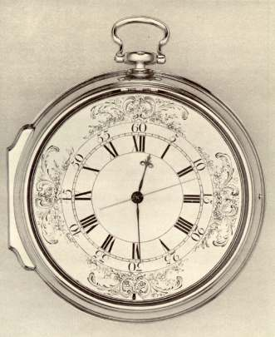
H4 from http://www.kellnielsen.dk/bol.htm
Even watches (oscillating balance wheel instead of a pendulum, and a spring rather than weights to provide energy) have thermal expansion problems, for example, as they warm up the spring provides slightly less force. Harrison compensated by inventing the bimetallic strip. That is a strip with two different metals welded together that expand at different rates and so the strip bends when heated. As his watch warmed up the bimetallic strips pulled in the balance wheel to compensate.
Repeated tests by the Navy showed H4 to be accurate enough for Harrison to be able to claim the longitude prize, which Parliament eventually paid out.
Ocean going watches for longitude calculations became standard equipment for shipping from then until GPS made them obsolete in this century.
Today Harrison’s bimetallic strips are still used as circuit breakers when things over heat, e.g. to trigger fire alarms.
The picture below shows a school experiment that could be used to test the bend on a bimetal at different temperatures.
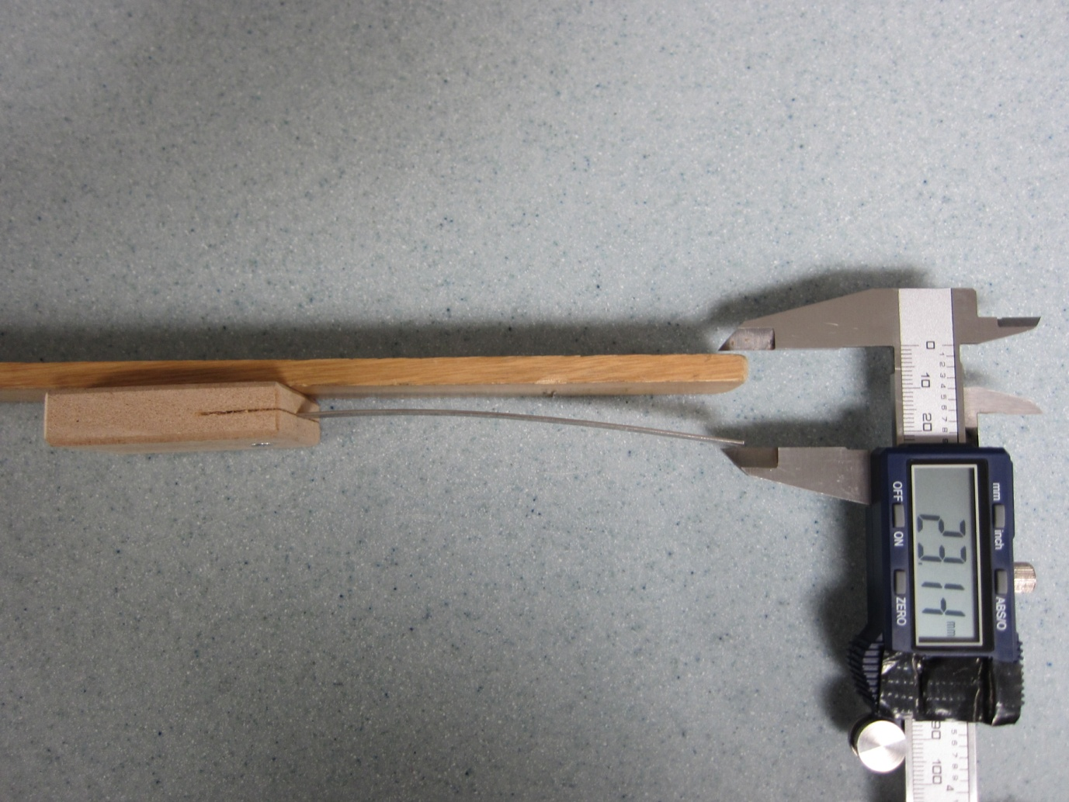
Solid ruler to provide a datum level
Digital Callipers
Bimetallic Strip

Task 6
Only carry out this task if you have class time left at the end of the project.
Looking at the picture above you can see that the strip has been heated to make it bend. If you were going to test the bend over temperatures from room temperature to 100ºC you would probably use boiling water.

Design a risk assessment for this bimetallic strip experiment:
Process that could pose a risk | Mitigating Actions

Sheet 21 is the last. Check that you have done both HW tasks, filled in all the supplementary questions on the sheets and included all graphs and tables before you hand your folder in.

References:
Two books were used in the production of this set of tasks
“Longitude”, D. Sobel, Fourth Estate 1996
“The Pendulum, a Case Study in Physics”, G. Baker & J. Blackburn, OUP 2008
The following pages from Wikipedia were used to check facts:
Universal Coordinated Time
Pendulum
Escapement
Bimetallic Strip
Other websites (particularly picture sources) are referenced in the text

